Schema Matching and Data Extraction over HTML Tables

A Thesis Proposal Presented to the
Department of Computer Science
Brigham Young University

In Partial Fulfillment of the Requirements
for the Degree Master of Science

Cui Tao

June, 2002

I. Introduction
Currently, with the fast development of the Internet, both the amount of useful data and the number of sites on the World Wide Web (WWW) is growing rapidly. The Web is becoming a very useful information tool for computer users. However, there are so many Web pages that no human being can traverse all of them to obtain the information needed. A system that can allow users to query Web pages like a database is becoming more and more desirable.

The data-extraction research group at Brigham Young University (BYU) has developed an ontology based querying approach, which can extract data from unstructured Web documents [Deg]. Although this approach improved the automation of extraction, it does not work very well with structured data. Hierarchically structured WWW pages, such as Web pages containing HTML tables, are major barriers to automated ontology-based data extraction. About 52% of HTML documents include tables [LN99a]. Although some of these tables are only for physical layout, there is still a significant part of online data that is stored in HTML tables.

The solution of querying data whose sources are HTML tables encompasses elements of table understanding, data integration, and information extraction. Table understanding allows us to recognize attributes and values in a given table. It is a complicated problem [HKL+01a]. Most research to date uses low-level geometric information to recognize tables [LN99b]. Some of the current geometric modeling techniques for identifying tabular structure use syntactic heuristics such as contiguous space between lines and columns, position of table lines/columns, and pattern regularities in the tables [PC97]. Some of the techniques take a segmented table and use the contents of the resulting cells to detect the logical structure of the table [HD97]. Others use both hierarchical clustering and lexical criteria to classify different table elements [HKL+01b]. So far, however, no known approach can provide a way to completely understand all formats of tables. Recent research on table understanding on the Web takes this research area to a higher level. SGML tags provide helpful information of table structures. But poor HTML table encoding, abuse of the HTML tags, the presence of images, etc, all challenge the full exploitation of information contained in tables on the Web [Hur01]. Existing approaches to determining the structure of an HTML table use source page pre-analysis ([HGM+97], [LKM01]), HTML tag parsing [LN99a], and generic ontological knowledge base resolution [YTT01].

The objective of schema mapping is to find a semantic correspondence between one or more source schemas and a target schema [DDH01]. The task of this research is to extract data from HTML tables to a target database. Therefore, we need to identify mappings from the source table schema to the target database schema. Past work on schema matching has mostly been done in the context of a particular application domain [RB01]. Furthermore, [RB01] points out that match algorithms can be classified into schema-level and instance-level, element-level and structure-level, and language-based and constraint-based matchers. Also, an implementation of match algorithms may use multiple combinations of these matchers [RB01]. In this thesis, we propose to detect schema mapping using an element-level matcher [MBR01] and an instance-level matcher [MHH00].

The problem of identifying the text fragments that answer standard questions defined in a document collection is called information extraction (IE) [Fre98]. Some IE techniques are based on machine learning algorithms [Mus99]; others are based on application ontologies ([ECJ+99], [ECS+98], [ECJ+98]). In this thesis, we intend to use ontology-based extractors as an aid to do element-level and instance-level schema matching.

With unknown structure, although general table understanding is a complicated problem, tables on the Web tend to be regular, almost always having their attribute in the top row. More specifically, HTML tables almost always have attributes in column headers with one attribute for each column. Therefore, in this research, we do not propose to deal with the general table-understanding problem. We focus on an interesting and useful problem: schema matching and data extraction over HTML tables from heterogeneous sources. There are several issues to resolve. We introduce these issues below.

Issues
Different Schemas
HTML tables do not have a regular and static structure as does data found in a relational database [HGMC+97]. Both schema and nesting may differ across sites. Even tables for the same application can have different schemas. For example, Tables 1-7 are all about automobile advertisements, but each one has a unique schema that is different from all the others.

Attribute-Value Pairs
Every table has a list of attributes (labels) and a set of value lists. Sometimes, the value and its corresponding attribute must be paired together to compose meaningful information. For example, in Table 1, observe that without the attributes, users cannot tell what the numbers in the “Dr” column or the letter in the “Tran” column are. But the attribute-value pairs “4 Dr” and “A Tran”, which means “Automatic Transmission”, are much better.
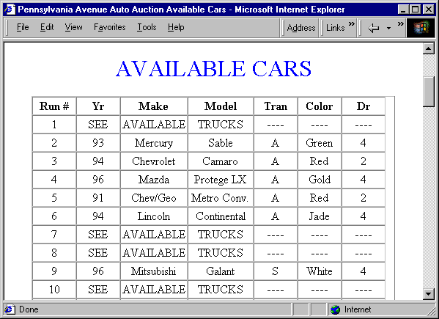
Table 1: A simple Web table from an automobile advertisement Web site

Value-Attribute Switch
An attribute in one table may be a value in another table and vice versa. For example, in Table 2, the attribute “Auto” may appear in the value cells for the attribute “Tran.” in Table 1. Further, the “Yes/No” values under “Auto” in Table 2 are not the values we want, Paths they indicate whether the car does (“Yes”) or does not (“No”) have automatic transmission. Similarly, the attributes “Air Cond.”, “AM/FM” and “CD”, which are attributes in Table 2, may appear as values of an attribute called “Features.”

Value/Attribute Combinations
One value in a single cell may describe multiple values in other tables. For example, the label “Vehicle” in Table 3 contains “Year” plus part of “Model,” “Number of Door,” “Transmission,” and “Color,” which correspond to five attributes in Table 1. It also contains information on the number of cylinders, which may be another attribute in some other tables.

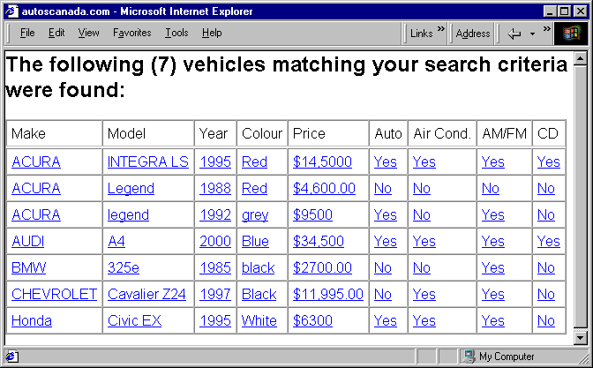
Table 2: A Web table containing conditions in the value cells

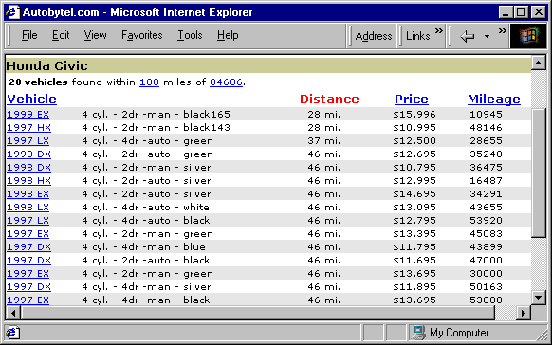
Table 3: A table with header from a different automobile advertisement Web site

Value Split
One value or attribute in a table may be described separately in another table. For example, the “Model” column value “Civic EX” in Table 2, is split into two parts in Table 4. The first part, “Civic,” is in column “Model”, and the second part, “ EX,” is under the attribute called “Trim.”

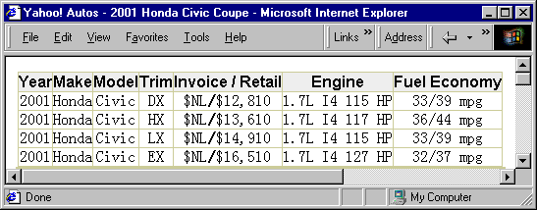
Table 4: An automobile advertisement Web site that contains split values

Header Information
In addition to the contents of the table, headers, or surrounding text can also provide useful information. For example, in Table 3, the header “Honda Civic” is not included in the table, but it supplies important information to the user.

Information Hidden Behind a link
Sometimes, a record in a table is linked to additional information. Table 5 shows an example, when the user clicks on the second link, Figure 1 appears. Linked pages may contain lists, tables, or unstructured data.

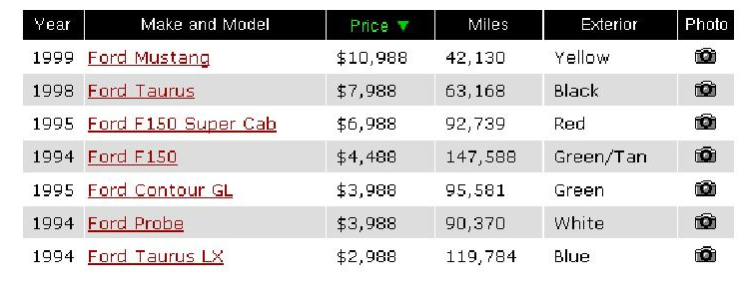
Table 5: A table with links
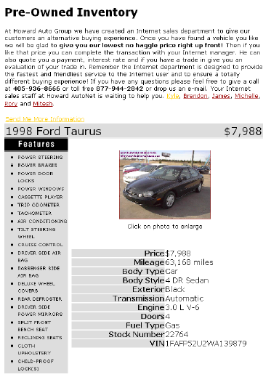
Figure 1: Additional information

Resolution
As illustrated, there are a number of problems to resolve. We may also encounter other issues. We believe, however, that all the issues can be resolved by the same general approach. For any table, we connect values and their attributes, and then divid tables into individual records. Given a record of attribute-value pairs, we should be able to extract individual values with respect to a target extraction ontology similar to the way we extract individual values for a target ontology from an individual unstructured or semistructured record. Because of the special layout and structure tables have, we know all the values under a single attribute in a source table should be extracted to the same set of attributes in the target schema. Given the recognized extraction and its regularity in the source document, we can measure how many values under a single source attribute are actually extracted to a particular set of target attributes. If the number is greater than a threshold, we can infer mappings between source and target attributes according to the regularity observed.
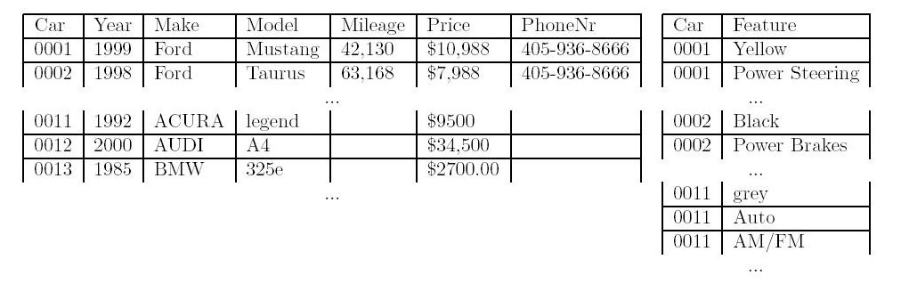
Figure 2: Sample Tables for Target Schema

For example, all the values under Year in Tables 2 and 5 were extracted as values for Year in the target schema (Figure 2). Therefore, the system can infer a mapping from Year in Table 2 or Table 5 to Year in the target schema. Using this same approach, the system can also infer a mapping from Yr in Table 1 to Year in the target schema. More generally, this method can also work for indirect mappings. For example, Make and Model in Table 5 should be split and map separately to Make and Model in the target schema. Both Exterior in Figure 5 and Colour in Figure 2 can map to Feature in Figure 2. The attributes Auto, Air Cond., AM/FM, and CD in Table 2 can be extracted as values for Feature in Figure 2, but only for ``Yes'' values. The inferred mappings not only can be applied from the structured source table schema to the target database schema, but also can be generalized to the semi-structured like pages. For example, if the system could extract most of the values list under Features in Figure 1 to Feature in the target schema, we can also declare a mapping from this list to Feature in the target schema.

II. Thesis Statement

In this thesis, we assume that we have a target application domain (e.g. car ads) and an extraction ontology for the application domain. We also assume that we have some documents that contain HTML tables for the application domain. We do not, however, know how these tables are structured. Under these assumptions, we propose a way to discover source-to-target mapping rules. We then use these mapping rules to develop a wrapper that can extract the textual information stored in applicable source HTML tables.

III. Methods

Our proposed table processing system contains seven steps. (1) We must first be able to recognize HTML tables. (2) After finding a table, we parse it and represent it as a tree. (3) We analyze the tree and produce attribute-value pairs. Sometimes, we may also need to transform either attributes or values and add factoring information. (4) If there is information hidden behind links, we need to preprocess the linked pages and add the information in the linked pages into their corresponding records. (5) We identify the individual records and create a source record document. (6) We perform pre-extraction and mappings from source to target schema. (7) Finally, we run the source record document with inferred mappings through the extraction process.

Recognize an HTML Table
An HTML document usually consists of several HTML elements. Each element starts with a start-tag <tagname> and ends with an end-tag </tagname>. Each table in a document is delimited by the tags <table> and </table>. In each table element, there may be tags that specify the structure of the table. For example, <th> declares a heading, <tr> declares a row, and <td> declares a data entry. We cannot, however, count on users to consistently apply these tags as they were originally intended.

Figure 3 shows the HTML source code of Table 4. It contains five <tr> elements, which indicates that the table has five rows. Within each <tr> element, there are seven <td> elements. Thus the table has seven columns. Observe in Table 4 that the first row contains a set of attributes, but its source code does not contain any <th> tag (heading tag). Developers often use <td> to declare attributes.

Since we are only interested in those HTML tables that have attributes on the top, usually, the first line of each table will be the table header (schema). In some special cases, however, there are headers within the table see Table 6). We will discuss this problem later.
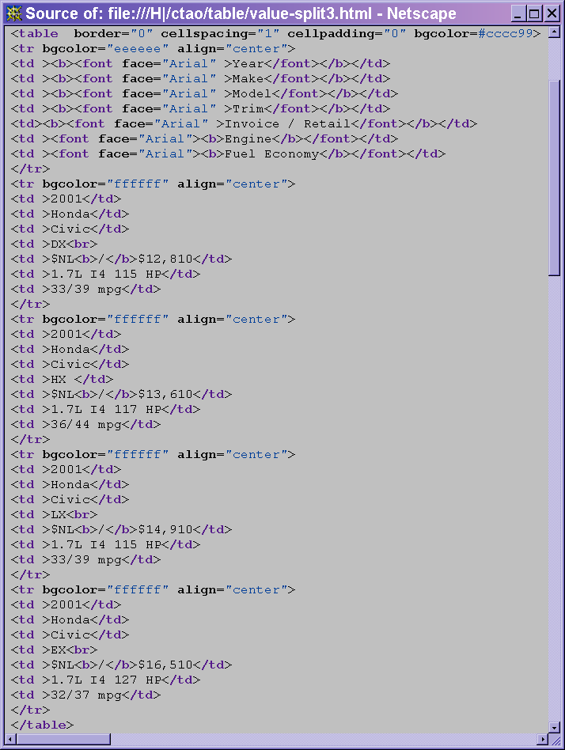
Figure 3. HTML source code of Table 4
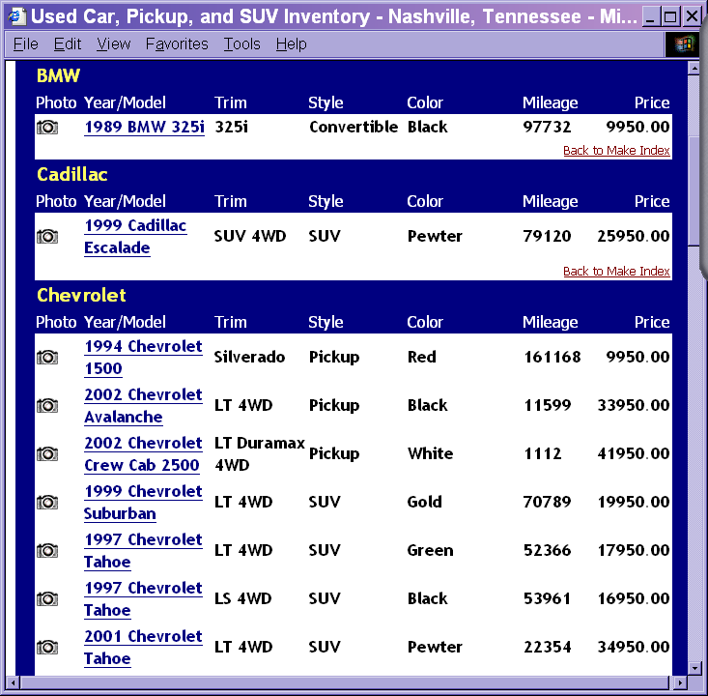
Table 6: An automobile advertisement table with external factoring

Parse the HTML Table
We first parse the HTML file and produce a DOM (Document Object Model) tree [Dom]. We then isolate the table elements. For example, Figure 4 is the DOM tree for Table 4. Observe that the leaves of the DOM tree are the data cells (either attribute or value) in the table of interest.
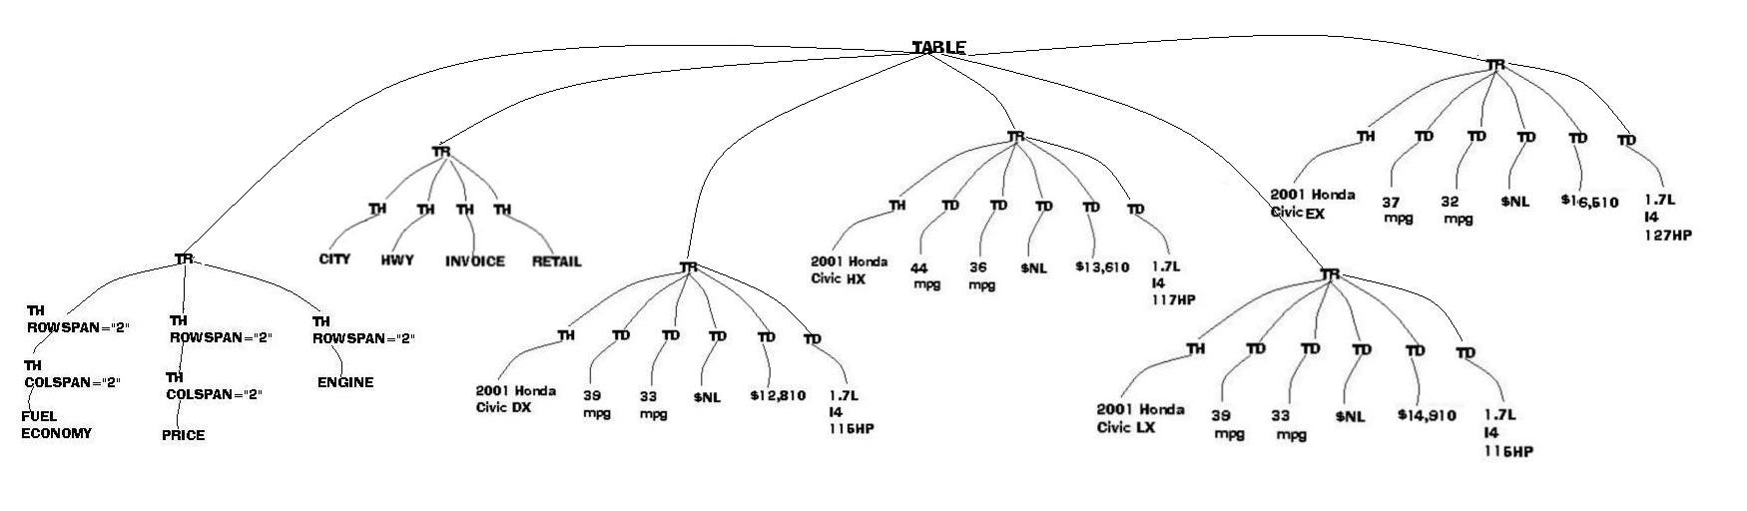
Figure 4: DOM tree of Table 4

Form Attribute-Value Pairs
After we obtain the DOM tree of each table in a document, we analyze and treat them one by one. As mentioned, sometimes values in the table do not mean anything without their corresponding attribute(s), and vice versa. Therefore, we need to create attribute-value pairs.

Find Attribute, Value and Table Factoring
Although we will only deal with tables that have attributes on top, we cannot simply assume that the first row of the table is the table schema and the rest of the rows are tuples. The first row in Table 6 is not the table schema, but the header information, factored out of the first car in the table. Also the fifth row and the ninth row contain “Cadillac” and “Chevrolet” respectively which are factored out of the cars below them. This information is in several of the rows, but our system should not misunderstand them as tuples; instead, the system should treat them as table headers.

Further, the fourth row and eighth row in Table 6 only contain “Back to Make Index”. This is not information about cars. Although they each take a new row, the system should not treat them as tuples. We can also observe in Table 6 that duplicate table header schemas exist. These duplicate schemas should not be treated as new tuples either.

We propose to solve these problems by using syntactic heuristics [PC97]. If there is a row in a table that has fewer columns than the most common number of columns in the table, then this row is assumed to contain external factoring information (table headers or footers). For example, the fifth row and the ninth row in Table 6 are headers. Each factors the tuples below until another header is encountered. We differentiate headers and footers by checking whether the first factoring of the table is above the first tuple or below it. Under this heuristic, of course, some irrelevant information such as the fourth row and the eighth row in Table 6 will also be treated as external factoring information. However, because they only contain irrelevant information (e.g. information not recognized by the application ontology), the ontology-based extractor will ignore them.

To find the schema of a table, we look for the first row that has most common number of columns in the table. If there is a subsequent row in a table that has exactly the same information as the schema of this table, the system will ignore this row.

Once we have identified attributes and eliminated duplicated rows, we can immediately associate each cell in the grid layout of a table with its attribute. If the cell is not empty, we also immediately have a value for the attribute and thus an attribute-value pair. If the cell is empty, however, we must infer whether the table has a value based on internal factoring or whether there is no value. Table 7 shows an example of internal factoring. The empty Year cell for the Cirrus LX with Stock number F706 is 2000 whereas the Sale Price for it is simply missing. We recognize internal factoring in a two-step process. (1) We detect potential factoring by observing a pattern of empty cells in a column, preferably a leftmost column or a near-leftmost column; (2) we check to see whether adding in the value above the empty cell helps complete a record by adding a value that would otherwise be missing.
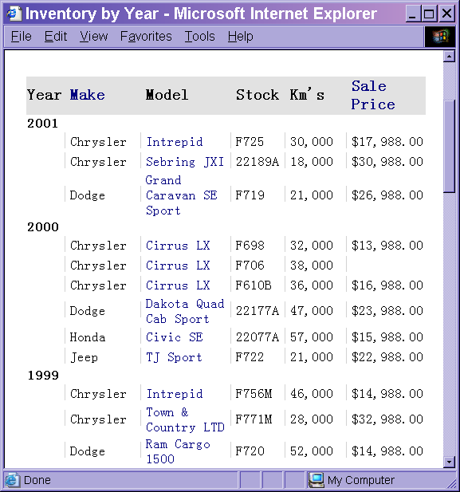
Table 7: An automobile advertisement table with internal factoring

Once we recognize the attributes, values and the factoring in a table, we can pair each value with its corresponding attribute.

Adjust Attribute-Value Pairs
Some values need to be considered specially. For example, Table 2 contains many Boolean values, such as “Yes” or “No”. The composed attribute-value pair will be “Auto Yes” (“Yes Auto”) or “Auto No”(“No Auto”). However, “Auto” itself is a term that can be extracted by the ontology-based extractor. It will be extracted provided it appears in the records. The “Auto No” actually means, “it is not auto.” One way to solve this problem is as follows. Whenever a Boolean value, such as “Yes,” appears in the value cells, instead of using the attribute-value pair, we use the attribute itself, and if the Boolean value means “No,” we leave the attribute-value pair blank.

Add Information Hidden Behind Links
If there is information hidden behind links, we need to preprocess the linked pages and add the information in the linked pages into their corresponding records. The information in the linked pages may be unstructured, semi-structured, or structured. For unstructured data in the linked pages, we simply attach all the information in the linked page to the corresponding record after removing all HTML tags. For structured data in the linked pages, we need to preprocess it in order to extract the data more effectively. Of the structures that can be formed by HTML tags, we are only interested in lists and single-record tables (explicit attribute-value pairs). For other structures, it is unnecessary to preprocess them and we will treat them as unstructured data.

Attribute-Value Pairs
We assume that a linked page corresponds to only one record in the original table. Therefore, it is highly likely that tables which appear in linked pages contain only a list of attribute value pairs. Figure 1 shows a simple example. Table 8 shows a more complex example: parallel sets of attribute-value pairs. Moreover, the attribute-value pairs can appear in different orientations: the attribute can be left-of (most common), above, right-of, or below (rare) the value.
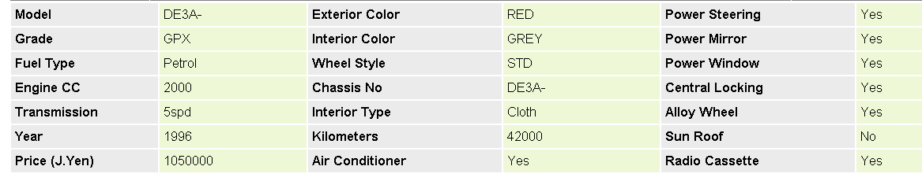
Table 8: An example table of attribute value pairs in linked page

For each table in a linked page, if the column number, m, or the row number, n, is even, we will treat this table as a potential group of attribute-value pairs. If either m or n is even, the table will be separated into m/2 or n/2 groups. Each group has a set of attribute-value pairs. After we pair them together and process the extraction, we check to see whether pairing them together will induce a more complete record. If m and n are both even, we try both. If we do not succeed in obtaining more completeness, we treat the table as a list as explained below.

List
Lists are either marked by <li> tags, or they appear in tables used for layout. We only need to find the beginning and ending of a list, which is trivial for <li> lists and straightforward for lists in tables used for layout. Figure 4 shows an example of a table used to make a list. Once we know that it is not an attribute-value-pair grouping, we simply designate it as a list and mark the beginning and the ending of the list in order to facilitate later inferred mappings.

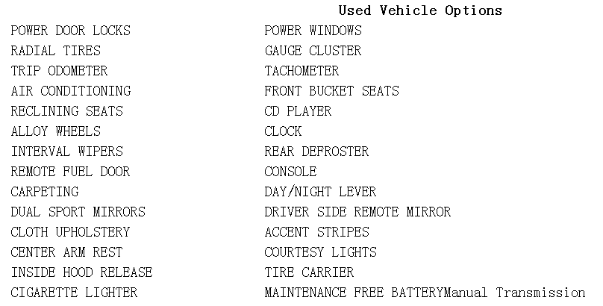
Figure 4: A table for physical layout which appears in a linked page

Identify Records
We then add the preprocessed link information into its corresponding data record to produce the record that is ready for the first round of data extraction.

Extract Data (Round one)
Once a record has been created, we apply our extraction ontology. We emphasize that our extraction ontology is capable of extracting from unstructured text as well as from structured text. Therefore, we can extract both the data in the table and the information in any unstructured linked pages. Sometimes, however, because the extraction ontology may not be sufficiently robust and the there may be misspelled or abbreviated words in the source table, not all the information in the source may be extracted. Nevertheless, we can create inferred mappings of source information to the target ontology which depend on special structures such as tables and lists in the source documents. Using these inferred mappings, we may be able to extract additional information.

Infer Mappings
By observing the correspondence patterns obtained when we extract tuples with respect to a given target ontology, we can produce a mapping of source information to our target ontology. Each mapping requires one or more operations. We use an augmented relational algebra to define our mappings. Some examples are list below.

- When source attribute names are the values we want and the values are some sort of Boolean indicator, we use a β operator to transform the Boolean indicators into attribute-name values. We define 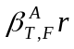 to mean a relation r with its values under attribute A which has Boolean values replaced by the attribute-name or empty string according to the Boolean indicator.

- We use the ε operator in conjunction with a natural join to add a column of constant values to a table. For example, the phone number 405-963-8666 appears in the linked pages (see Figure 1) under Table 5, we could apply 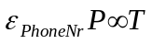to add a column for PhoneNr to table T in Figure 2.

- For a table that has internal factored values, we need to unnest the table. Here we use the μ operator to do the unnesting. For example, we can record the semantic correspondence of Table 7 and the target schema as the mapping: .

- For merged attributes we need to split values. Here we use the δ operator to divide values into smaller components. We define 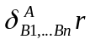 to mean that each value v for attribute A of relation r is split into v₁… v_{n}, one for each new attribute B₁… B_{n} respectively.

- For split attributes we need to merge values. Here we use the γ operator to gather values together under their corresponding target attribute. We define 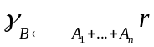 to mean a new attribute B of the relation r and each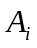 is either an attribute of r or is a string that scattered in the linked pages.

We can also use this standard set operators to help sort out subsets, supersets, and overlaps of value sets.

Extract Data (Round Two)
After we discover all the mappings, we can perform the second round of data extraction and save the final results in a local database.

Evaluation
In order to evaluate the performance of our approach, we consider two types of evaluation measures:
- We can measure the percentage of the correct mappings, partially correct mappings, and incorrect mappings. We consider a mapping declaration for a target attribute to be completely correct if it is exactly the same mapping as a human expert would declare, partially correct if it is a unioned (or intersected) component of the mapping, and incorrect otherwise.
- We can measure the precision ratio and recall ratio for the data in the table and the data under links.
- We can do this both for extracted data before mappings are generated and for extracted data after mappings are generated. We can also measure the difference between extracted data and mapped data.

We plan to test our approach over three different application domains. Each domain will have at least 30 testing tables.

IV. Contribution to Computer Science
This research provides an approach to extract information automatically from HTML tables. It also suggests a different approach to the problem of schema matching, one which may work better for the heterogeneous HTML tables encountered on the Web. We transform the matching problem to an extraction problem over which we can infer the semantic correspondence between a source table and a target schema. The approach we introduce here add to the work being done by the ontology-based extraction research group.

V. Delimitations of the Thesis
This research will not attempt to do the following:
- Consider HTML tables other than tables with all attribute names at the top.
- Consider the meaning of symbols, images and colors in the tables.
- Process tables in the linked pages that can not be understood by the heuristics we listed in the method section.
- Extract information from tables not formatted by HTML.
- Extract information from ill-formed HTML tables.
- Handle HTML tables that are not written in English.

VI. Thesis Outline
1. Introduction (6 pages)
1.1 Introduction to the Problem
1.2 Related work
1.3 Overview of the thesis
2. Single Table Investigation (8 pages)
3.1 Find and parse tables
3.2 Pair Attribute-Value Pairs
3.3 Create Records
3. Complete Record Generation (8 pages)
3.1 Preprocess the information in the linked pages
3.2 Create Complete Records
4. Create Inferred Mapping (10 pages)
4.1 Operator Definitions
4.2 Inferred Patterns and generated operator sequences
5. Experimental Analysis (6 pages)
5.1 Experimental Discussions
5.2 Results
5.3 Discussion
6. Conclusions, Limitations, and Future Work (4 pages)

VII. Thesis Schedule
A tentative schedule of this thesis is as follows:
Literature Search and Reading January – December 2001
Chapter 3 September 2001– May 2002
Chapter 4 February 2002– June 2002
Chapters 1 and 2 May 2001 – October 2002
Chapters 5 and 6 May 2002 - October 2002
Thesis Revision and Defense November 2002

VIII. Bibliography
[DDH01] A. Doan, P. Domingos, A. Halevy. Reconciling schemas of disparate data sources: A Machine-Learning Approach. In Proceedings of the ACM SIGMOD Conference on Management of Data, May 21-24, Santa Barbara, California, 2001.
This paper introduce a system that can find mappings from a multitude of data sources schema to a target schema using machine learning algorithms.

[Deg] Brigham Young University data extraction group homepage. http://www.deg.byu.edu
[Dom] The W3C architecture domain. http://www.w3.org/DOM/
[ECJ+99] D. W. Embley, D. M. Campbell, Y. S. Jiang, S. W. Liddle, D. W. Lonsdale, Y.–K. Ng and R. D. Smith, Conceptual-model-based data extraction from multiple-record Web pages. In Data & Knowledge Engineering, 31 (1999) pp.227-251.
This paper introduces a conceptual-modeling approach to extract and structure data automatically. This approach is based on an ontology, a conceptual model instance that describes the data of interest, including relationships, lexical appearance, and context keywords.

[ECS+98] D. W. Embley, D. M. Campbell, R. D. Smith, and S. W. Liddle, Ontology-based extraction and structuring of information from data-rich unstructured documents, In Proceedings of 7th International Conference on Information and Knowledge Management (CIKM’98), pp. 52-59, Washington, D. C., November 1998.
This paper presents an ontology approach that can extract the information from unstructured data documents.

[ECJ+98] D.W. Embley, D. M. Campbell, Y. S. Jiang, Y.-K. Ng, R. D. Smith, S.W. Liddle, and D.W. Quass, A conceptual-modeling approach to extracting data from the Web, In Proceedings of 17th International Conference on Conceptual Modeling (ER’98), pp. 78-91, Singapore, November 1998.
This paper introduces an ontology-based conceptual-modeling approach to extract and structure data. By parsing the ontology, the system can automatically generate the database schema and extract the data from unstructured documents and structure it according to the generated schema.

[Fre98] D. Freitag. Information extraction from HTML: application of a general machine learning approach. In American Association for Artificial Intelligence, pp. 26-30, Madison, Wisconsin, July 26-38 1998.
This paper introduces a top-down relational algorithm for information extraction and show how information extraction can be cast as a standard machine learning problem.

[HD97] M. Hurst and S. Douglas, Layout and Language: Preliminary investigations in recognizing the structure of tables in Proceedings of ICDAR’97, August 18-20, 1997 in Ulm, Germany
This paper introduces an approach which can distinguish different table components based on a model of tables structure combined with several cohesion measures between cells. The cohesion measures present in this paper are very simple. Therefore, only the simplest tables can be understand well.

[HGM+97] J. Hammer, H. Garcia-Molina, J. Cho, R. Aranha, and A. Crespo. Extracting
semistructured information from the Web. In proceedings of Workshop on
Management of Semistructured Data, Tucson, Arizona, May 1997.
This paper describes a tool for extracting semistructured data from HTML tables and for converting the extracted information into database objects. The extractor needs an input that specifies the states where the data of the interested is located on the HTML documents and how the data should be packaged into objects. For each HTML page, the extractor needs one corresponding input. Therefore, the tool cannot work well if there is any change in the source HTML pages.

[HKL+01a] J. Hu, R. Kashi, D. Loresti, G. Nagy, and G. Wilfong. Why table ground-truthing is hard. In Proceedings of the Sixth International Conference on Document Analysis and Recognition, pp. 129-133, Seattle, Washington, September, 2001
This paper presents a detailed analysis of why table ground-truthing is so hard, including the notions that there may exist more than one acceptable “truth” and/or incomplete or partial truth. The tables discussed in this paper are not only HTML tables, but also include all other tables.

[HKL+01b] J. Hu and S. Kashi and D. P. Lopresti and G. Wilfong, Table structure recognition and its evaluation in Proceedings of Document Recognition and Retrieval VIII , SPIE , San Jose, CA. USA, 2001,C.
This paper describes a general approach, which can recognize the structure of a given table region in ASC II text based on table DAG (Direct Acyclic attribute Graph). The system prefers homogeneous collection of documents with simple structures. It also cannot capture hierarchical row headers, which leads to incorrect understanding of sametables. To increase performance, syntactic and semantic elements of documents should be considered both for table detection and recognition.

[Hur01] M. Hurst, Layout and language: challenges for table understanding on the Web Proceedings of the First International Workshop on Web Document Analysis (WDA2001) Seattle, Washington, USA September 8, 2001 (in association with ICDAR'01)

This paper discusses some of the challenges that are faced in table understanding. Impoverished HTML table encoding, abuse of the HTML tags, the presence of images, etc, all suggest the challenges of the full exploitation of information contained in tables on the Web.

[LKM01] K. Lerman, C. A. Knoblock and S. Minton, Automatic Data Extraction from Lists and Tables in Web Source. In Automatic Text Extraction and Mining Workshop (ATEM-01), IJCAI-01, Seattle, WA, August 2001.
This paper describes a technique that can automatically extract data from semistructured Web documents containing tables and lists by exploiting the regularities in the format of the pages and the data in them. However, the induction of the wrapper needs the pro-analysis of at least one page in one source.

[LN99a] S. -J Lim and Y. -K Ng. An automated approach for retrieving hierarchical data from HTML tables. In Proceedings of the 8th International Conference on Information Knowledge management (ACM CIKM'99), pp. 466-474, Kansas City, MO, USA, November 1999.
This paper introduces an approach to convert HTML tables into pseudo-tables. More specifically, it can convert tables that have complicated structure into simple tables that have only a single set of attributes. Then a content tree can be created that depends on the pseudo-table. This approach tries to determine the hierarchy of HTML tables that depends only on HTML tags such as <TR>, <TD>, <TH>, <COLSPAN> and <ROWSPAN>, but ignoring useful information provided by special features of tables such as duplicate values and the meaning of the fonts and styles of the table contents. Therefore it can only deal with a part of HTML tables. Furthermore, this paper only gives a way to understand table structures, further research needs to be done in order to integrate the information in tables and query source data in tables.

[LN99b] D. Lopresti and G. Nagy. Automated table processing: An (opinionated) survey. In Proceedings of the Third IAPR Workshop on Graphics Recognition, pp.109-134, Jaipur, India, September 1999.
This paper gives a list of tables and analyzes each of the table. It identified several classes of potential applications for table processing and summarizes the difficulties involved in table processing.

[MBR01] J. Madhavan, P. A. Bernstein and E. Rahm, Generic schema matching with Cupid. In Proceedings of the 27th VLDB Conference, Roma, Italy, 2001.
This paper first provides a survey and taxonomy of past schema matching approaches. It then presents a new algorithm, Cupid, which improves on past methods in many respects. Cupid discovers mappings between schema elements based on their names, data types, constraints, and schema structure, using a broader set of techniques than past approaches. However, Cupid cannot distinguish between the instances of a single attribute in multiple contexts. It also depends on a thesaurus to match schema names.

[MHH00] R. J. Miller, L. M. Haas and M. A. Hernandez, Schema mappings as query discovery. In Proceedings of the 26th VLDB Conference. Cairo, Egypt, 2000.
This paper discusses the difference and similarity between schema mapping and schema integration. The authors also introduce an interactive paradigm based on value correspondences that show how a target attribute can be created by a set of source attributes. Given a set of value correspondences, a mapping query must to be created to transform from the source schema to the target schema.

[Mus99] Ion Muslea. Extraction patterns for information extraction tasks: survey. In American Association for Artificial Intelligence (www.aaai.org), Orlando, Florida. July 18-22, 1999,
In this paper, the authors survey the various types of extraction patterns that are generated by machine learning algorithms, identify three main categories of existing extraction patterns and give a comparison of these three patterns, which cover most of application domains.

[PC97] P. Pyreddy and W. Bruce Croft, TINTIN: A system for retrieval in text
tables, in Proceedings of the 2nd ACM International Conference on Digital
Libraries, PP. 23-26, Philadelphia, Pennsylvania, July, 1997
This paper introduces a system that can extract tables from documents, decompose each table into different table components such as table entry and caption. After decomposition, then system then uses the structural decomposition to facilitate better representation of user’s information needs. This system is SGML tags independent. It uses syntactic heuristics other than semantic ones. It can extract table from document and distinguish some of the table headings from table entries. But for some cases such as when the headings and table entries have the same layout format, it cannot find the correct table components. After the decomposition, this system only stores the table components for their information retrieval purpose. It does not deal with any integration problem.

[RB01] E. Rahm, P. A. Bernstein, A survey of approaches to automatic schema matching. In the VLDB Journal 10: 334-350 (2001).
This paper presents a survey and taxonomy that cover many existing schema matching approaches. The authors distinguish between schema-level and instance-level, element-level and structure-level, and language-based and constraint-based matchers and describe the solution cover of each approach and discuss the combination of multiple matchers. This paper is a useful resource for schema matching research.

[YTT01] M. Yoshida, K. Torisawa and J. Tsujii, A method to integrate tables of the World Wide Web, in Proceedings of the International Workshop on Web Document Analysis (WDA 2001), pages 31-34, Seattle, Washington, USA , September 8, 2001.
This paper presents an approach, which can automatically recognize table structures on the basis of probabilistic models where parameters are estimated by the EM algorithm. This approach requires generic ontological knowledge. Therefore, it is application dependent.

IX. Artifacts
We will implement the proposed algorithm as a tool/demo that can be used to extract information stored in HTML tables, infer operations, create SQL statements to insert the extracted information into a database, and display the results.

X. Signatures

This proposal, by Cui Tao, is accepted in its present form by the Department of Computer Science of Brigham Young University as satisfying the proposal requirement for the degree of Master of Science.

____________________ ___________________________________
Date David W. Embley, Committee Chairman

____________________ __________________________________
Date Stephen W. Liddle, Committee Member

____________________ __________________________________
Date Thomas W. Sederberg, Committee Member

____________________ __________________________________
Date David W. Embley, Graduate Coordinator

