AUTOMATIC EXTRACTION OF INDIVIDUAL AND FAMILY INFORMATION FROM TRANSCRIBED PRIMARY GENEALOGICAL RECORDS

by
Charla Woodbury

A thesis proposal submitted to the faculty of
Brigham Young University
in partial fulfillment of the requirements for the degree of

Master of Science

Department of Computer Science
Brigham Young University
October 2006

ABSTRACT

AUTOMATIC EXTRACTION OF INDIVIDUAL AND FAMILY INFORMATION FROM PRIMARY GENEALOGICAL RECORDS

Charla Woodbury
Department of Computer Science
Master of Science

There is great interest in family history research on the web and a great many competing genealogical websites that contain large amounts of data-rich, unstructured, primary genealogical records. The problem is that it is so labor-intensive even after making these records machine-readable, for humans to make the same records searchable. What we need are computer tools that can automatically produce indices and databases from the data-rich, unstructured genealogical records and can identify individuals and events, determine relationships, and put families together. The solution is a specialized ontology, built specifically for the information extraction of primary genealogical records, with expert logic and rules to infer genealogical facts and assemble relationship links between persons with respect to the genealogical events in their lives.

The deliverables of this solution are a specialized ontology used to extract parish or town records, a marked-up version of the original document, a data file of individuals and events, and rules used to define family relationships and manipulate the data file, linking families from those records. The results are evaluated in terms of the measurement of recall and precision of the classification by record type, the correct extraction of the data-rich information, and the correct grouping of families.
- Introduction

One of the most popular pursuits on the Internet is genealogy or family history research. The Internet is perfect for sharing family information and for publishing completed research. Popular genealogical research sites have some of the highest webpage hit statistics recorded. The Ellis Island immigration website was brought to its knees within minutes by enthusiastic family history researchers. The website
was deluged by users. Eight million visitors logged on in the first eight hours, and officials estimated that 85 percent were being turned away. US News & World Report called it “the most popular launch in Internet history” [Wen01].

It took more than three months to make the improvements that would allow the website to stay online.
The many family history websites on in the Internet are in high competition to provide large systems of primary records that are easily and quickly searched by naïve users. For example, almost all the major family history websites have indexed United States census data from 1850 to 1930. Users look up names and places by searching indices that finally link to digital images of the original census pages. The human effort to enter and index information from handwritten census pages is staggering, especially considering that many use double entry of the data to remove input errors.
So far, family history sites such as Ancestry.com [www.ancestry.com], Family Tree Maker [www.familytreemaker.com], Heritage Quest [www.heritagequest.com], etc. have used large traditional relational databases. Manual data entry is generally used to populate those databases and to link those databases to digital images of the original primary documents. The Church of Jesus Christ of Latter-Day Saints, for example, has organized large numbers of people to manually index such projects as passenger lists and census information. Using the computer to automatically organize and index primary genealogical records would be a major shift in approach for all these organizations.
What is needed is a smarter and a faster way of producing searchable primary genealogical records and using the computer to identify individuals and family relationships. Dallin Quass, the keynote speaker at the 2003 Family History Technology Workshop [Qua03], stated that we need “faster image indexing.” He also said “People currently index images manually” by using “two independent indexers and adjudication” which involves tremendous human effort. He indicated that simplistic indexing of records and images is not enough. We need to link records: “Given a person in a pedigree and a large set of genealogical records, do any of the records match?”
The development of the semantic web has produced toolsets that aid a computer in its ability to “understand” the meaning of a word in a particular subject domain. Scientists like Maedche et al. [MNS02] and Embley [Emb04] have suggested using lexical knowledge, extraction rules, and modeling to add semantic understanding to computer programs. Tools like ontologies with regular expressions and lexicons can be used to organize and give meaning to large amounts of unstructured, primary genealogical records in or out of the semantic web. And best of all, this toolset can be used today.
The functionality of the semantic web toolset, however, needs to be expanded to add specialized domain expertise for genealogical records. Once this expertise is defined and corresponding ontologies built, then machine-readable genealogical records will be automatically indexable and fully searchable. If fully successful, this means that every bit of genealogical information in the primary records can be used to qualify an individual and that all of this information is indexed. For example, records often include an individual’s occupation, or place of residence, or witnesses present, which are very helpful in differentiating individuals with the same name, but are rarely available in a simple name index. Words recognized as occupations will be labeled and semantically recognized as occupations by the computer.
If the information extraction process can be fully automated and combined with the technology to make handwritten records machine-readable, family history companies could prepare searchable primary records without large data-entry teams. Expert logic could be used to make the machine do more of the work, both for extraction and indexing, as well as partially assembling families. Researchers could pull partial or even whole families pre-assembled out of a parish or town register.
The purpose of this research is to automate the information extraction process on unstructured genealogical records by:
- designing a primary record extraction ontology of family history research;
- labeling primary genealogical records with ontological annotations for easy searching;
- grouping individuals into families using expert rules and constraints; and
- testing and evaluating the results for accuracy by computing recall and precision measures.

- Related Work
Dallin Quass was one of the first to use information extraction in the field of family history. He has had a great deal of experience using information extraction with companies such as Whizbang and Junglee and has applied that expertise to developing a new non-profit organization, Foundation for On-Line Genealogy, with a website for genealogical searching called WeRelate (http://www.werelate.org). It combines a web search-engine for genealogical research as well as a wiki containing names and places where researchers can share information.
Burdette Pixton recently used data mining tools to link family records for the same individual. Specifically, he started with indexed genealogical records and built a filtered, structured neural network using back propagation and previously prepared pedigrees so that he could exploit family relationships in genealogical terms [Pix06].
Outside the family history domain, the field of information extraction has shown promise in providing a way of handling unstructured text. Many researchers have identified this method as the solution. Popov et al. [PKM+03] suggested that fully automatic information extraction was the answer to understanding information on the web. Andrew McCallum [McC05] states that the majority of data on the web is locked in unstructured formats and that information extraction is the key to setting it free.
Brigham Young University’s Data Extraction Group has developed a tool called Ontos [ECJ+99], which has successfully interpreted and labeled data in such specialized areas as car ads and death notices. For each focus area (e.g. car ads), an ontology was built with surprising success at labeling data in search pages with various formats and from various sources. Focusing on primary genealogical records such as a complete parish register is larger in scope than highly specialized vocabularies used for car ads and has not yet been successfully achieved.
All of this work has laid a good foundation, but has not completely solved the problem of automatic handling of unstructured genealogical records. We propose to make it possible to do automatic extraction of complete parish registers and to assemble families from these registers by using an expert ontology. This proposal also builds upon the work done with Ontos to divide genealogical information into separate records [WE04] and the work done to query annotated information by Ontos [Vic06].
- Thesis Statement
To interpret and correctly label machine-readable genealogical data and place it in a fully-searchable format, a specialized ontology can be built specifically for information extraction of primary genealogical records, with expert logic and rules to correctly extract information and to group individuals into families.

- Project Description
The project has four major steps:
- Prepare for genealogical information extraction and family linking.
- Run a first pass that extracts information from genealogical records.
- Run a second pass that applies rules to match individuals and to link family members.
- Evaluate and optimize the results.
  - Preparing for Genealogical Information Extraction and Family-Building
There are several components of the project that need to gathered or built. We will need to do the following:
- Develop a specialized extraction ontology that uses typical data recognizers as well as expert logic and specially developed genealogical lexicons.
- Obtain machine-readable files of an English parish, a Danish parish, and vital records from one New England town.
    - Ontology Building
An ontology consists of both high-level and low-level descriptions of what the entities are and how they are related to other entities. Ontos [ECJ+99], developed by the Data Extraction Group at Brigham Young University, allows ontology designers to create ontologies by using modeling techniques. The basic component of an ontology is an object set. The objects or values in an object set are described by a data frame that “encapsulates knowledge about the appearance, behavior, and context of a collection of data elements” [Emb80]. Relationships among objects are captured in relationship sets. Constraints, such as cardinality constraints, serve to constrain object and relationship sets.
Lexicons list all possible values for a particular entity. See Figure 1, which contains part of a Danish Given Name Lexicon, for an example of a lexicon that will be used. Multiple spellings and abbreviations must be anticipated in a lexicon and thus prepared before using the ontology. Once successfully built, these lexicons can be re-used in new projects in the same domain. Lexicons are added to the ontology for given name, patronymic name (Danish only), surname, feast date, place name, occupation, and family relationship. Problems such as abbreviations, misspelled words, and multiple

Danish Given Name LEXICON
MALE
Anders And.
Andreas
Christen Kristen
Christian Kristian
Erik Eric
Gregers
Hans
Ib Jep Jeppe
Jacob
Jens
Johan Johannes Joh.
Jorgen Jørgen
Knud
Lars Laurs Laurids Lauritz
Mads Mats Mats
. . .

FEMALE
Ane Anna Anne
Birthe Birte
Bodil
Caroline
Dorthe Dorte
Ellen Helene Elene
Elisabeth Elsbeth Lisbeth
Else Ilse
Ingeborg
Inger
Karen
Kirsten Christen Kirstine Christine Kirstine Chirstine
Malene
Maren
. . .

. . .
Figure 1: Partial lexicon for Danish given names before 1900
languages will be handled in the lexicons. Languages also need to be anticipated. For the project, English, Danish, and Latin lexical words will be needed in each lexicon.
Functionality also needs to be added to the data frames to handle conversion problems and to trigger the recognition of appropriate strings. For example, functions will be included that will
- canonicalize values for dates, names, and places;
- compute an approximate birth date from age at the time of death; and
- calculate the day and month from feast dates such as Easter 1751.
    - Machine-readable Files of Parish and Town Records
For data, we will use primary genealogical records of an English parish, a Danish parish, and vital records from one New England town. Although machine-readable, these source files will not be pre-formatted in any way. Some are published and read in using an optical character reader; otherwise, they will be as though an optical character reader had just dumped the information into a text file.
The English parish will be Wirksworth, Derby, England (1608-1813), which was transcribed by John Palmer from the original microfilm records. His website is http://www.wirksworth.org.uk/Index.htm.
The Danish parish will be the Magleby Parish, Praesto, Denmark (1646-1813), which I transcribed many years ago when my own genealogical research kept tracing back again and again to that parish. It is an exact copy of the original Danish and Latin text preserving abbreviations and missing parts of the record. In addition, Danish parish records will come from a webpage of marriages for Skanderborg Amt (county) transcribed by Erik Brejl, who is a Danish archivist at http://www.brejl.dk/vielser.htm. These records contain 6,743 marriages for Nim, Norvang, Torrild, Tyrsting, Voer, and Vrads districts in Skanderborg before 1814. Figure 2 shows part of this record.
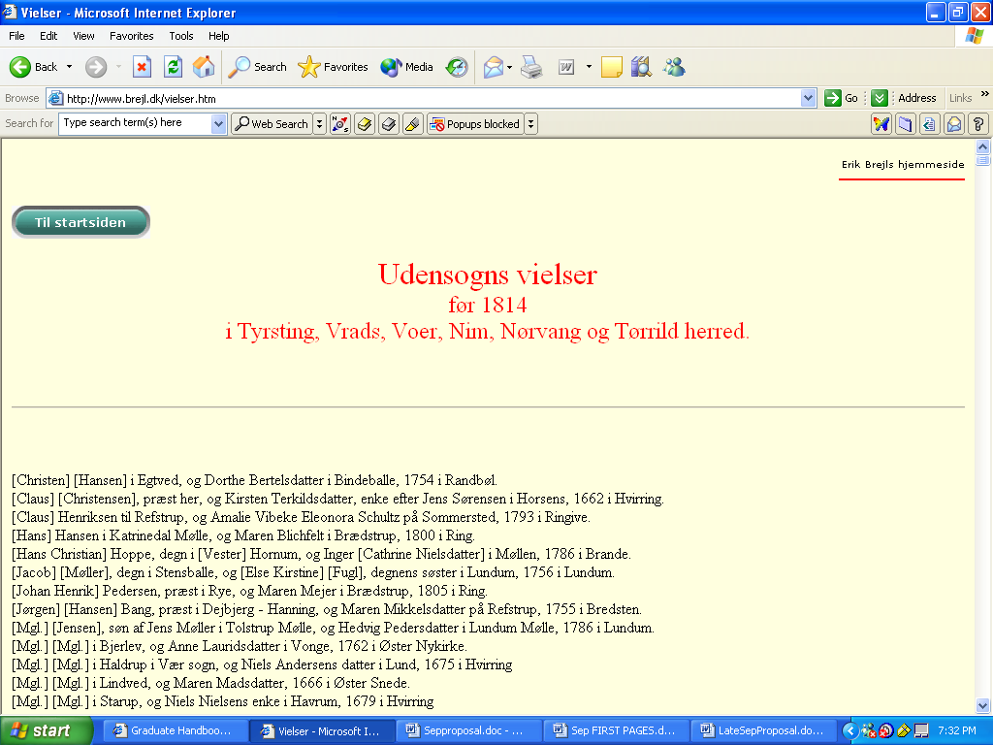
Figure 2 Erik Brejl's list of Skanderborg marriages before 1814

The New England town record will be the town of Beverly, Essex, Massachusetts (1668-1849), which was published many years ago. These records will be scanned in using OCR technology.
  - Running the First Pass that Extracts the Information
The first pass will extract information about individuals and events that will
- produce an annotated version of the original parish or town record and
- populate the RDF data file with individuals and link basic family relationships.
    - The Annotated Genealogical Record
One of the deliverables of this project will be a semantically annotated version of the original, machine-readable records. Semantic annotations are extra mark-ups that add semantic definitions to words or groups of words.
The annotated version of the original primary genealogical records will be a webpage consisting of a list of data records — one for each register entry in the source document. Each record will include a URL pointing back to the actual original record now annotated. This URL consists of a link to the annotated document, plus an offset that equals the exact location in the document where this entry was found in the original source. This final annotation of the original register is one of the products that will be available for searching.
    - The Populated RDF Data file
The RDF data file will be the final receptacle of individuals and family data. This data file, designed by Hilton Campbell, will be a repository of RDF triples using the structure described in his “Genealogy Core” [Cam06]. There are two types of data:
- person data that describes each individual and
- event data that describes each birth, marriage, death, etc.
Each person points to at least one event that corresponds directly to a record entry, such as a marriage with a date and a URI link to the original record. The linking between events and persons, and between persons to other persons, will be expressed in RDF graphs.
The Genealogy Core is well developed and is flexible enough to allow ambiguous data like multiple mothers and complex relationships like adoptive parents, as well as act as a large-scale receptacle of RDF data for genealogy. It can be manipulated by JRDF (Java RDF) as described at http://jrdf.sourceforge.net/. The relations between triples are structured as graphs using the JRDF graph API. Families are described in terms of graphs or relationships.
As the extraction ontology processes and marks up the original genealogical record file, the RDF data file is populated with triples that define persons and events. 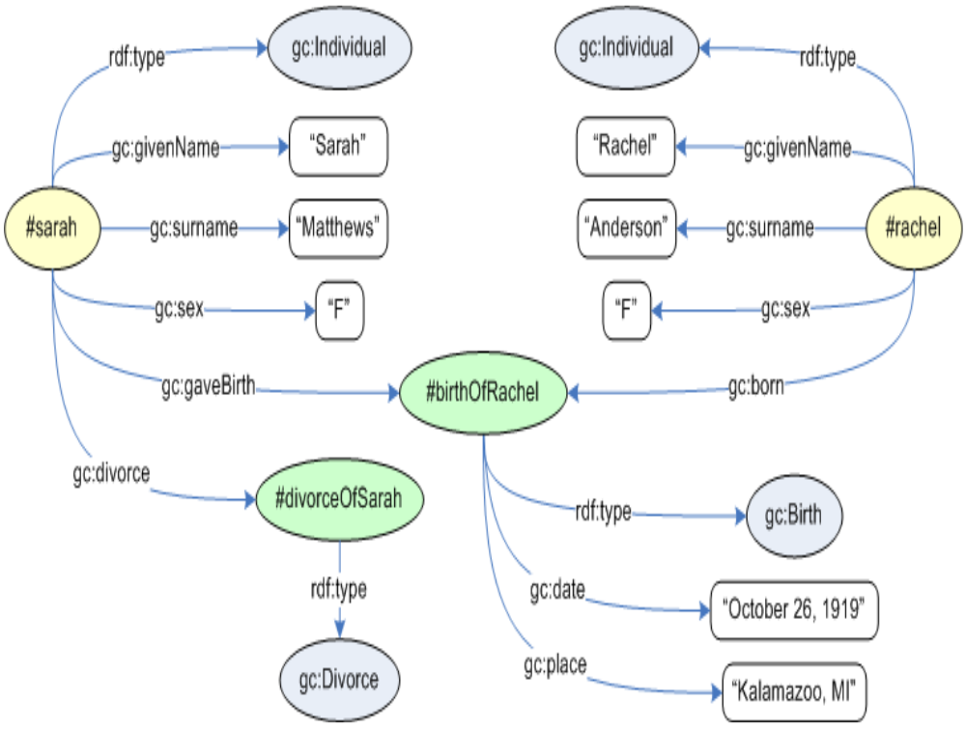 Figure 3 The RDF graph of a birth event
After the first pass, every name listed in the parish record will constitute a person in the RDF data file. See Figure 3 for an example of how the data will be organized in the data file. It shows the RDF graph of the person Sarah Matthews and the person Rachel Anderson, linked by the event “birthOfRachel”, which has a date and a place. In the same way, every record entry will constitute an event that has person(s) pointing to that event.
Part of the extraction process of the first run will be to label the record entries correctly as to whether they are a birth, christening, marriage, etc. The record entry label may not seem important at first, but it determines the kind of event and how specific aspects of the record are processed and formatted. If the entry is labeled correctly, then the date is labeled correctly. In a birth record, the date becomes a birth date; whereas the date in a burial record becomes a burial date. A correct label also suggests the format of the entry information and how it should be stored in the RDF data file. For example, if the record is a christening, then the computer expects the name of the child and the names of the parents, whereas a marriage record expects the names of a husband and a wife.
This identification should become apparent as the regular expressions in a non-lexical object set designating the record type recognize particular context keywords. For example, a christening record would contain words like christening, christened, baptized, baptism, chr., bp., bapt., daab, dobt, db. If the entry record type cannot be determined, then the record entry will be labeled “misc” for miscellaneous.
  - Running the Second Pass that Applies the Rules to the RDF-data
We run the second pass that applies the logic rules and constraints across the RDF file. The work of the second pass will be to
- formulate rules in Rule Engine language that will best
  - match individuals,
  - check family data,
  - link up families, and
- apply the rules to the RDF-file through the Java Rules API.
    - Rules Formulation
There are advantages to using rules rather than writing code to manipulate data:
- Rules that represent policies are more easily communicated and understood.
- Rules retain a higher level of independence than conventional programming languages.
- Rules separate knowledge from its implementation logic.
- Rules can be changed without changing source code; thus, there is no need to recompile the application's code.
The Rule Engine language is very simple, yet powerful. We will only need a text file to define the rules. Yet using multiple definitions to define PERSON properties, very complex ideas can be expressed. For example, suppose that we want to define a predicate called “hasProperMotherAgeRangeFor” which allows us to set the upper and lower bounds of the ages that we can expect mothers to have children. Assume that we have previously defined the following properties:
- Sex – the RDF triple (#rachel, Sex, ‘F’) expresses that PERSON with key #rachel has Sex = ‘F’.
- hasChild - the RDF triple (#rachel, hasChild, #john) expresses that PERSON with key #rachel has a child who is a PERSON with key #john.
- hasBirthYear – the RDF triples (#rachel, hasBirthYear,1726) and (#john, hasBirthYear, 1767) expresses that PERSON with key #rachel has a birth or christening date with a year part equal to 1726 and that PERSON with key #john has one equal to 1767.
Now we wish to verify that Rachel was between the ages of 12 and 60 when her child was born. This rule in Rule Engine language would look like this:
(?p hasChild ?c)
(?p sex ‘F’)
(?p hasBirthYear ?b1)
(?c hasBirthYear ?b2)
Difference (?b2, ?b1, ?a)
gt (?a, 12)
lt (?a, 60)
      - (?p hasProperMotherAgeRangeFor ?c)

The language is robust enough to express ideas recursively. Here is an example of the definition of the property “IsAncestorOf” as a recursive statement:
(?p hasChild ?c)
-> (?p IsAncestorOf ?c)

(?a IsAncestorOf ?p)
(?p IsAncestorOf ?c)
-> (?a IsAncestorOf ?c)

There are operators already defined in JavaRules. One pre-defined operator ― SIMILAR ― is an operation that can test two names or places to discover if they are close enough to be variations of the same name or place. Using rules like these, we can match and merge persons and thus assemble families. For example, a child in a christening record with named parents can be compared to a husband in a marriage record with a named wife. The computer can compare and find that the child and husband are similar enough to be merged and linked.
    - Rules Application
New rules may be discovered and included in the process. Exact logical and mathematical definitions for each constraint and rule will be developed and tested for the thesis. Each rule will add consistency to the data in the RDF-file as well as link PERSON’s into families. If it is found that the father in six birth entries is merged as the “same person”, then the result of that merge is a family with links to six children.
Once all rules and constraints have been applied, the logical container will be populated with rich family information. Each family may range from just a single PERSON to a complicated network of relationships of generations of PERSON’s. The resultant family groups of PERSON’s will be fascinating to family history researchers. Figure 4 shows a small example of an RDF graph.

  - Evaluating and Optimizing the Results
There are several steps needed to improve identification of events and persons and to better group families. We will need to do the following:
- Evaluate the preliminary results. Using precision and recall measurements as defined in section 5, we will evaluate the preliminary results of applying the rules and determine how to improve the application of the rules.
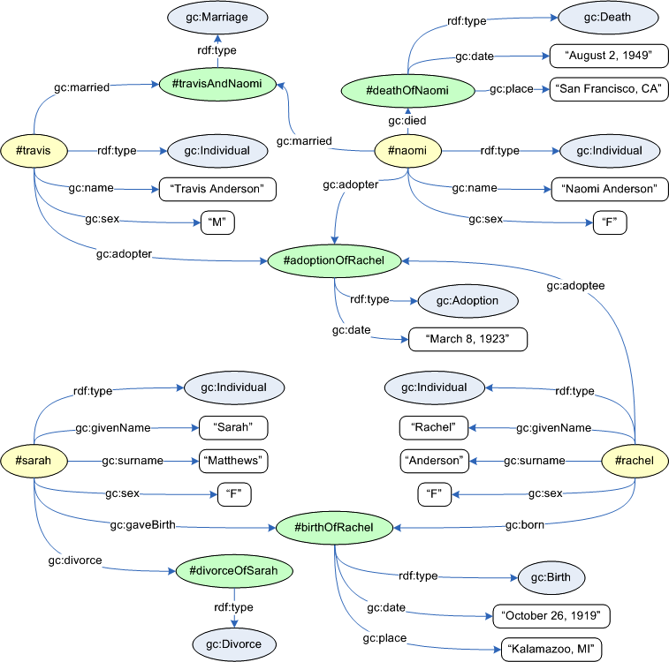
Figure 4 An example of a person linked to events and other persons

- Optimize the rules. By adding rules, removing rules, fine-tuning a rule, or changing the order that the rules are applied to the RDF data file, we can optimize the application of the rules.
- Improve the recall and precision. This will be an iterative discovery process that may be repeated many times depending on the evaluation.
Once the process is improved, we can run the whole process against the complete genealogical record. Of course, we will need to re-evaluate and optimize as we proceed. Hopefully, we will be able to determine how to best apply the whole process to a new record and location.

- Validation
With an ontology built to extract information from unstructured primary genealogical records of parish and town records, and with internal expert logic and reasoning in the form of methods and rules and constraints, each entry in the records can be annotated. The resulting annotated record from the ontological search can then be evaluated in terms of precision and recall. An entry is a single record event in the parish or town record, such as a single christening.
Recall and precision statistics will be measured based on following definitions.
- Recall statistics of classification by record_type — Number of entries classified correctly for record type t divided by the total number of t type entries.
- Precision of classification by record_type — Number of entries classified correctly for record type t divided by the total number of entries classified by the program as record type t.
- Precision of the extracted information from the genealogical records — Number of textual objects for object set s labeled correctly divided by the number of textual objects that were labeled for object set s.
- Recall of the extracted information from the genealogical records — Number of textual objects for object set s labeled correctly divided by the number of textual objects actually belonging to object set s.
- Grouping by family — Families will be grouped by merging ‘person’ records and by splitting ‘person’ records into more families when an inconsistency is found. Total number of merges and splits needed to correctly form families generated from the results of the second pass divided by the total number of merges and splits needed to correctly form families from the results of the first pass. A lower number would be the better result.
As the logic and rules are fine-tuned, the precision and recall statistics should improve. The fine-tuning will continue until the results no longer significantly improve. It is anticipated that the process will work better when more detailed information is available.

- Thesis Schedule
There will be four phases in the thesis work:
- Research phase
- Ontology and lexicon building phase
- Coding/development phase
- Actual writing of the thesis
The first three phases may overlap, since the research (specifically the reading of publications regarding similar research) will undoubtedly continue. However, the majority of the research and reading will be done by December 31, 2006, and the coding done by April 30, 2007. The writing and defense of the thesis will be done by the conclusion of summer term on August 15, 2007.

- Annotated Bibliography
[Cam06] H. Campbell. Genealogy Core Tutorial. June 2006. http://www.nucleartoiletpaper.com/genesis/gc-tutorial.htm.
This paper defines an RDF methodology for defining data about individuals and their links reflecting the real-world relationships of human families. This is the definition of the RDF data file used in this proposal.

[ECJ+99] D.W. Embley, D.M. Campbell, Y.S. Jiang, S.W. Liddle, D.W. Lonsdale, Y.-K. Ng, and R.D. Smith. Conceptual-model-based data extraction from multiple-record webpages. Data & Knowledge Engineering, 31(3):227-251, November 1999.
This paper presents the BYU Ontology software ‘Ontos’ and its application as a model for the information extraction. This ontology software will be used in the “first pass” to extract the information from genealogical records.

[Emb80] D.W. Embley. Programming with data frames for everyday data items. Proceedings of the 1980 National Computer Conference, pages 301-305, Anaheim, California, May 1980.
This paper introduces the concept of data frames for organizing unstructured data and is the basis of my methodology.

[Emb04] D.W. Embley. Towards semantic understanding: An approach based on information extraction ontologies. In Proceedings of the Fifteenth Australasian Database Conference, pages 3-12, Dunedin, New Zealand, January 2004.
This paper suggests using information-extraction ontologies to produce semantic understanding of information by using modeling techniques, lexicons, and logical rules. My project will use modeling, lexicons, and logical rules.

[McC05] A. McCallum. Information extraction: distilling structured data from unstructured text. Social Computing, 3(9):350, Amherst, Massachusetts, November 2005.
This paper discusses how information extraction can be used to make information that is locked in unstructured, natural language freely available for searching. This is exactly what this proposal will do. I will turn unstructured information into information that can be freely searched.

[MNS02] A. Maedche, G. Neumann, and S. Staab. Bootstrapping an ontology-based information extraction system. Intelligent Exploration of the Web, pages 345-359, Physica-Verlag GmbH, Heidelberg, Germany, 2002.
This paper presents the development of ontologies. The concepts of lexical knowledge, extraction rules, and ontology modeling are detailed here as general ontological practice. This proposal uses lexicons, rules, and modeling.

[Pix06] B. Pixton. Improving records linkage through pedigrees. Master’s thesis, Computer Science Department, Brigham Young University, Provo, Utah, August 2006.
This thesis presents a filtered structured neural network solution using back propagation methods and pedigree data to successfully link records that identify an individual from multiple sources and constitutes related work that also puts families together, but by using a very different methodology.

[PKM+03] B. Popov, A. Kiryakov, D. Manov, A. Kirilov, D. Ognyanoff, and M. Goranov. Toward semantic web information extraction. In Proceedings of the ISWC’03 Workshop on Human Language Technology for the Semantic Web and Web Services, pages i-xxii, Sanibel Island, Florida, October 2003.
This paper presents introductory concepts for fully automating information extraction which suggests the need for a fully automatic solution. This proposal presents a fully automatic solution using information extraction.

[Qua03] D. Quass. Perspective on research problems in family history from the LDS Family and Church History Department, Family History Technology Workshop, Provo, Utah, March 2003. (http://www.fht.byu.edu/prev_workshops/workshop03/).
This keynote presentation introduces the need for better text extraction from original sources to improve searching genealogical records online. This goal is the hope of this proposal.

[Vic06] M. Vickers. Ontology-based free-form query processing for the semantic web. Master’s thesis, Computer Science Department, Brigham Young University, Provo, Utah, June 2006.
This thesis presents an Ontos solution for query processing and presenting the query results. This query processing will be incorporated into my solution.

[WE04] T. Walker and D.W. Embley. Automatic location and separation of records: A case study in the genealogical domain, In Proceedings of the International Workshop on Conceptual Model-directed Web Information Integration and Mining (CoMWIM04), pages 302-313, Shanghai, China, November 2004.
This paper uses Brigham Young University’s ontology tool (Ontos) to separate one record from the next in a genealogical listing. This record separation will be incorporated into my solution.

[Wen01] S. Wenner. Getting on the island. Family Tree Magazine, October 2001. (http://www.familytreemagazine.com/articles/oct01/ellissite.html).
This news article documents the opening of the Ellis Island webpage
at www.ellisisland.org. It illustrates the intense interest in family
history on the Internet.

BRIGHAM YOUNG UNIVERSITY

GRADUATE COMMITTEE APPROVAL

of a thesis submitted by
Charla Woodbury

This thesis has been read by each member of the following graduate committee and by majority vote has been found to be satisfactory.

___________________ | ______________________
Date | David Embley, Chair
___________________ | ______________________
Date | Deryle Lonsdale
___________________ | ______________________
Date | Daniel Zappala
___________________ | ______________________
Date | Parris K. Egbert
 | Graduate Coordinator

